**BME 313L: Introduction to Numerical Methods in Biomedical Engineering**

**Lab Report**

**Lab #7 Chapter 13: Eigenvalues**

**Last name, First name:**

**EID:**

**Lab Section: Tuesday, Wednesday, Thursday, Friday**

**Problem 1. From textbook Problem 13.2 (Power Method)**

Use the power method to determine the highest eigenvalue and corresponding eigenvector for

$$\left[\begin{matrix}2-λ & 8 & 10 \\ 8 & 4-λ & 5 \\ 10 & 5 & 7-λ\end{matrix}\right]$$

**Things to discuss**

(1) Describe the details of the algorithm of power method and how it was implemented in this problem.

(2) The smallest eigenvalue and its associated eigenvector can be determined by applying the power method to the matrix inverse of [A] (textbook p.312), why?

(3) The example 13.3 in the textbook has a high approximate relative percentage at the fourth iteration, but it does converge and stabilize on the largest eigenvalue. Why don’t we observe the similar fluctuation in this problem?

**MATLAB code:**

**MATLAB function:**

**Results:**

**Discussion:**

**Problem 2. From textbook Problem 13.11**

A system of two homogeneous linear ordinary differential equations with constant coefficients can be written as

$$\frac{dy_{1}}{dt}=-5y_{1}+3y_{2} \\ \frac{dy_{2}}{dt}=100y_{1}-301y_{2}$$

$y_{1}\left(0\right)=50, y_{2}\left(0\right)=100$.

The solutions for such equations have the form

$$y_{i}=ce^{λt}$$

where $c$ and $λ$ are constants to be determined. Substituting this solution and its derivate into the original equations converts the system into an eigenvalue problem. The resulting eigenvalues and eigenvectors can then be used to derive the general solution to the differential equations. For example, for the two-equation case, the general solution can be written in terms of vectors as

$$\left\{y\right\}=c_{1}\left\{v_{1}\right\}e^{λ_{1}t}+c_{2}\{v_{2}\}e^{λ_{2}t}$$

where $\left\{v_{i}\right\}=$ the eigenvector corresponding to the $i^{th}$ eigenvalue ($λ_{i}$) and the $c'$ s are unknown coefficients that be determined with the initial conditions.

(a) Use MATLAB to solve for the eigenvalues and eigenvectors. Print them in the command window.

(b) Employ the results of (a) and the initial conditions to determine the general solution (analytical expression), and develop a MATLAB plot of the solution for $t=0$ to $1$.

**Things to discuss**

(1) Describes the function of eig

(2) Describe how to solve the problem mathematically.

**MATLAB code:**

**MATLAB function:**

**Results:**

**Discussion:**

**Problem 3. From textbook Problem 13.12**

Water flows between the North American Great Lakes as depicted in Fig. 1. Based on mass balances, the following differential equations can be written for the concentrations in each of the lakes for a pollutant that decays with first-order kinetics:

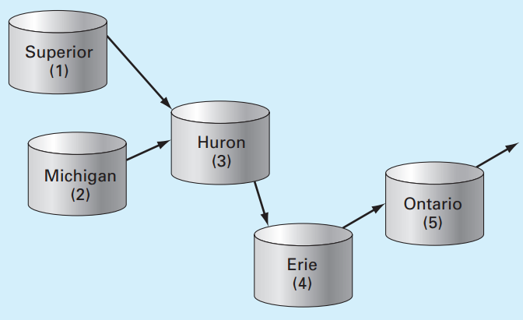

Figure 1. The North American Great Lakes. The arrows indicate how water flows between the lakes.

$$\frac{dc_{1}}{dt}=-\left(0.0056+k\right)c_{1} \\ \frac{dc_{2}}{dt}=-\left(0.01+k\right)c_{2} \\ \frac{dc_{3}}{dt}=0.01902c_{1}+0.01387c_{2}-\left(0.047+k\right)c_{3} \\ \frac{dc_{4}}{dt}=0.33597c_{3}-\left(0.376+k\right)c_{4} \\ \frac{dc_{5}}{dt}=0.11364c_{4}-(0.133+k)c_{5}$$

where $k=$ the first-order decay rate (/yr), which is equal to 0.69315/(half-life). Note that the constants in each of the equations account for the flow between the lakes. Due to the testing of nuclear weapons in the atmosphere, the concentrations of strontium-90 (90Sr) in the five lakes in 1963 were approximately $\left\{c\right\}={\left\{17.7 30.5 43.9 136.3 30.1\right\}}^{T}$ in unites of Bq/m3. Assuming that no additional 90Sr entered the system thereafter, *use MATLAB and the approach outlined in Problem 2 to compute and plot the concentrations in each of the lakes from 1963 through 2011*. Note that 90Sr has a half-life of 28.8 years.

**Things to discuss**

(1) Describe how to use the eigenvectors and eigenvalues to determine the general solution for the concentrations of 90Sr in each of lakes (analytical expression).

(2) Use the plot you generate to discuss the changes of concentrations in each of the lakes and the relationships between lakes.

**MATLAB code:**

**MATLAB function:**

**Results:**

**Discussion:**